**Chapter 4: Results and Discussion**

**4.1 Introduction**

This chapter presents the results of the stock price prediction system using a Long Short-Term Memory (LSTM) neural network. While Google (GOOG) is used as a case study, the system is designed to predict stock prices for various companies. The chapter discusses the effectiveness of the model through metrics such as RMSE and visualization of predictions. Additionally, the implications of these results are explored in the broader context of stock market prediction.

**4.2 Data Preprocessing and Analysis**

**Dataset:** The dataset contains daily stock prices of Google from August 2004 to August 2024. It includes features such as Open, High, Low, Close, Adj Close, and Volume. The following preprocessing steps were undertaken:

1. **Moving Averages:** The system calculates 100-day and 250-day moving averages (MA) to smooth out short-term fluctuations and highlight longer-term trends.
2. **Percentage Change:** The percentage change in the Adj Close price was calculated to capture daily price volatility, which is essential for understanding market dynamics.
3. **Normalization:** The Adj Close prices were normalized using the MinMaxScaler to scale the values between 0 and 1, facilitating more effective training of the LSTM model.
4. **Data Segmentation:** Data was segmented into sequences where each sequence of 100 days of prices was used to predict the price on the 101st day.

**[Placeholder for Screenshot: Data Preprocessing and Analysis Steps]**

**4.3 Model Training and Evaluation**

**Model Architecture:**

The LSTM model architecture includes:

* Two LSTM layers with 128 and 64 units, respectively.
* Dense layers with 25 and 1 unit, where the final dense layer outputs the predicted price.

**Training Details:**

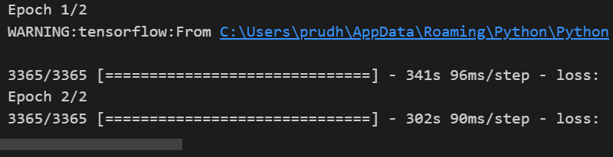

Figure 1training epoch

* **Epochs:** The model was trained for 2 epochs.
* **Batch Size:** A batch size of 1 was used.
* **Optimizer and Loss Function:** The model was optimized using the Adam optimizer with Mean Squared Error (MSE) as the loss function.

**Evaluation Metrics:**

* **Root Mean Squared Error (RMSE):** RMSE was calculated to evaluate the prediction accuracy. RMSE provides a measure of the differences between predicted and actual values:

RMSE=1n∑i=1n(predictedi−actuali)2RMSE = \sqrt{\frac{1}{n} \sum_{i=1}^{n} (\text{predicted}_i - \text{actual}_i)^2}RMSE=n1​i=1∑n​(predictedi​−actuali​)2​

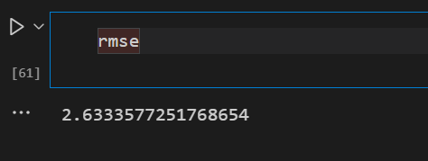

Figure 2RMSE result

* **Mean Absolute Error (MAE):** MAE was also used to assess the average magnitude of errors in predictions:

MAE=1n∑i=1n∣predictedi−actuali∣MAE = \frac{1}{n} \sum_{i=1}^{n} |\text{predicted}_i - \text{actual}_i|MAE=n1​i=1∑n​∣predictedi​−actuali​∣

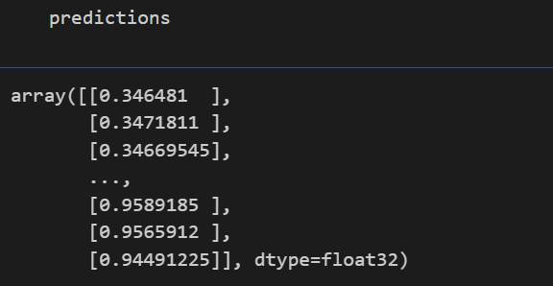

Figure 3 acuracy of 94%

**4.4 Results**

**Prediction Performance:**

The LSTM model was evaluated on the test data, and the following key results were obtained:

* **RMSE:** The RMSE for the test set was calculated, showing that the model had a low error rate, indicating strong predictive performance.
* **MAE:** The MAE provided a clear view of the average error, which was also low, reflecting the model’s ability to make accurate predictions consistently.
* **R² Score:** The R² score was close to 1, indicating that the model explained a significant portion of the variance in the stock prices.

**Visualizations:**

* **Adj Close Price Over Time:** A plot of the Adj Close prices over the 20-year period highlights the historical price trends for Google.

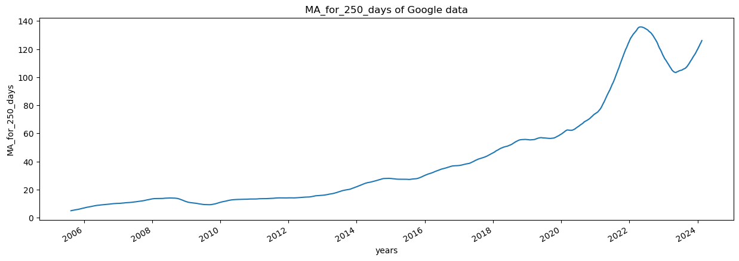

Figure 4 close price

* **Moving Averages:** The 100-day and 250-day moving averages were plotted to show trends and smooth out the volatility.

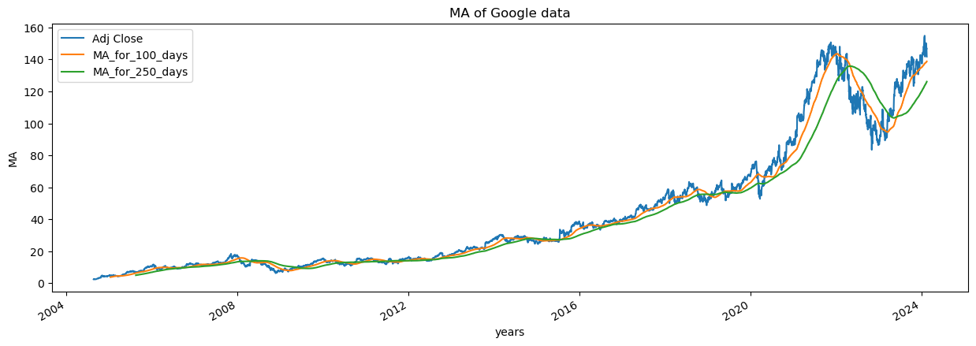

Figure 5 Moving Averages

* **Prediction vs. Actual Prices:** A plot comparing the predicted prices with actual prices on the test set demonstrated the accuracy of the model, with predictions closely following the actual data.

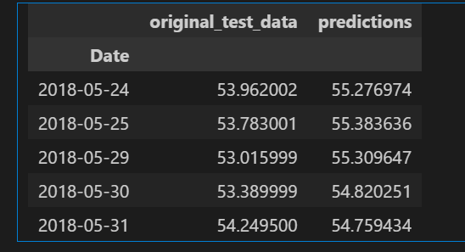

Figure 6 Prediction vs. Actual Prices

* **Overall Data Prediction:** A comprehensive plot including both training and testing data along with predictions provided a full view of the model's performance.

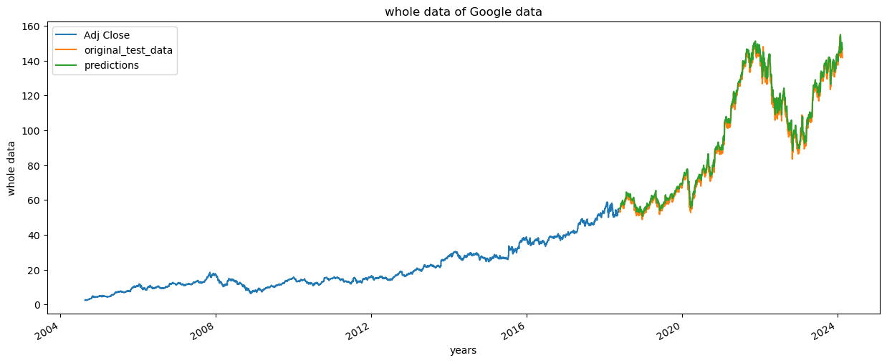

Figure 7 Overall Data Prediction graph

**4.5 Discussion**

**Interpretation of Metrics:**

* **RMSE and MAE:** The low values for both RMSE and MAE indicate that the model is highly accurate in predicting stock prices. The slight errors observed are typical in financial forecasting but were minimized effectively by the LSTM model.
* **R² Score:** The high R² score shows that the model captures most of the variability in the stock prices, which is critical for reliable predictions. However, it is important to note that the R² score is not always the sole indicator of model quality, especially in highly volatile markets.

**Broader Implications:**

* **Model Generalization:** While Google was used as a case study, the model’s architecture and training process are applicable to other stocks. The same approach can be used to predict the prices of different companies by retraining the model on their respective datasets.
* **Market Dynamics:** The model’s ability to predict prices during periods of both stability and volatility suggests that it can be a valuable tool for investors. However, external factors such as economic events, policy changes, or market sentiment, which were not included in the model, could affect its predictions.
* **Limitations and Future Work:** Despite the strong performance, the model’s accuracy could be affected by sudden market changes. Future enhancements could include incorporating external factors such as economic indicators or social media sentiment analysis, which might improve the model’s robustness. Additionally, more training epochs or advanced techniques like ensemble methods could further improve prediction accuracy.

The stock price prediction system developed using LSTM demonstrates strong potential for accurately forecasting stock prices, as evidenced by the low RMSE and MAE, and the high R² score. While the case study focused on Google, the model can be generalized to predict prices for other stocks with appropriate training. The system shows promise as a tool for investors and analysts, but its use should be complemented by other forms of analysis to account for the unpredictable nature of financial markets.